Philadelphia University
Faculty: Science
Department: Basic sciences
Exam time 75 min.

Date: 14/ 12/ 2021 General Chemistry for Health Science 0212109
Midterm exam A
Name: …………………………… Student No. : …………..………………

Section: ……………… Instructor Name : …………..………….
Q1) (1 points each)
Direction: Each of the question bellow is followed by four suggested answers. Select the one that is best in each case and type it in the above table.

1. | a. | b. | c. | d. | 8. | a. | b. | c. | d.
2. | a. | b. | c. | d. | 9. | a. | b. | c. | d.
3. | a. | b. | c. | d. | 10. | a. | b. | c. | d.
4. | a. | b. | c. | d. | 11. | a. | b. | c. | d.
5. | a. | b. | c. | d. | 12. | b. | c. | d. | a.
6. | a. | b. | c. | d. | 13. | b. | c. | d. | a.
7. | a. | b. | c. | d. | 14. | b. | c. | d. | a.
Useful data: Avogadro’s No = 6.022 × 10²³
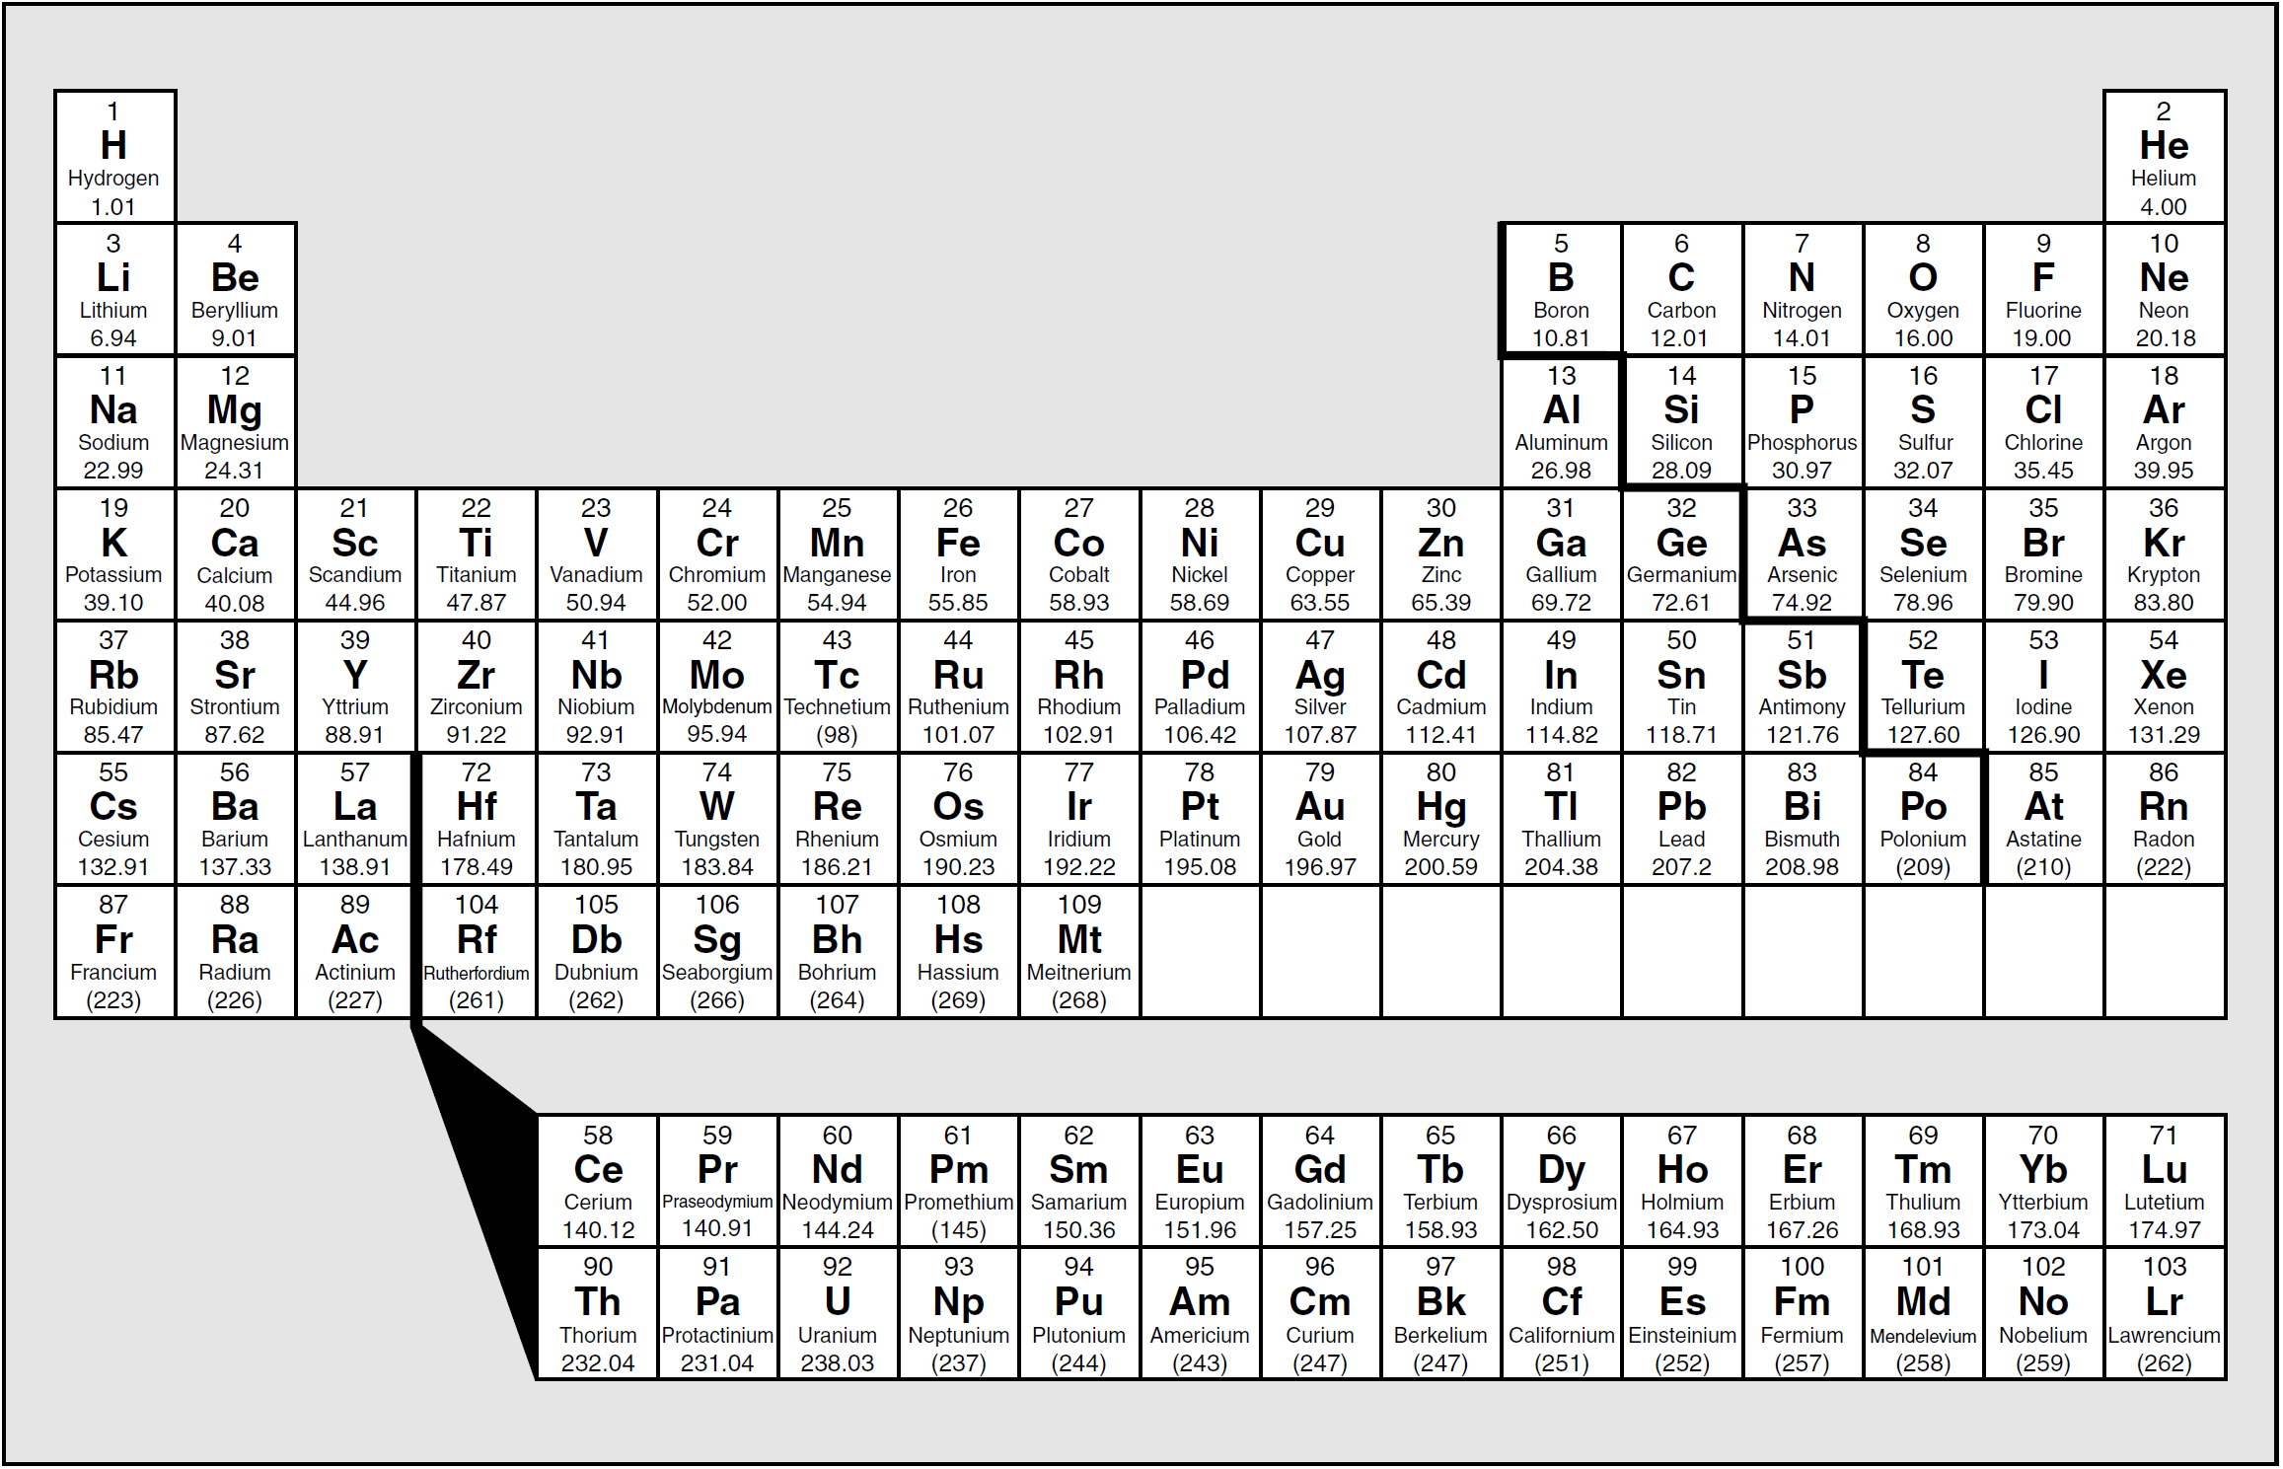
- Carry out the following answer with the correct number of significant figures?
(1.2 + 21.28 ) / 5.10 =
- 4.4 B) 4.41 C) 4.408 D) 4.4078

- All of the following are Diatomic molecules except :
- O₂ B) HCl C) H₂O D) F₂

- The coefficient in front of O₂ in the reaction 2C₂H₆ + …O₂ → 6H₂O + 4CO₂ is :
- 2 B) 3 C) 5 D) 7

- Which of the following formulas could be considered as empirical formula?
- N₂H₂ B) C₆H₆ C) H₂O D) C₆H₁₂O₆

- The Fahrenheit temperature which is equal to 317.5 K is :
- 45.4 B) 80.1 C) 112.1 D) 144.4

- A metal cube has a volume of 7.43 cm³ and a mass of 77.0 g. What is the density of the metal in g/m³?
- 5.65×10⁸ B) 1.05×10⁷ C) 5.65×10⁶ D) 1.05×10⁵

- The prefix which related to the value of 10⁻⁹ is :
- milli B) micro C) nano D) centi

- The oxidation number of Cl in the chlorate ion is :
- +3 B) +4 C) +5 D) 1

- The molarity of solution prepared by dissolving 2.8 g of KOH in 50. mL
- 2.0 mol/L B) 1.0 mol/L C) 0.50 mol/L D) 4.0 mol/L

- In the following reaction Ca + HCl CaCl₂ + H₂
Which statement is FALSE ?
- Calcium is oxidized C) Hydrogen is reduced
- Hydrogen is oxidized D) Cl ion neither reduced nor oxidized

- The name of compound N₂O₄ is
- Nitrogen oxide B) Dinitrogen oxide C) Dinitrogen tetraoxide D) Trinitrogen tetraoxide

- The number of electrons in S²⁻ ion is
- 20 B) 18 C) 16 D) 10

- The volume of a 0.20 M HCl solution is needed to neutralize 10.0 mL of a 0.300 M NaOH solution is:
- 20.0 mL B) 15.0 mL C) 25.0 mL D) 30.0 mL

- The volume needed from 5.00 M KMnO₄ solution to prepare a solution of 35.0 mL, 1.66 M KMnO₄ solution is:
- 58.1 mL B) 29.1 mL C) 11.6 mL D) 8.30 mL
____________________________________________________________________
Q2) Answer the following questions about compound P₄O₁₀? ( 3 Points )
- The type of compound is (Ionic or Molecular or Metallic) :

- Calculate the mass percent of phosphorus (P) ?

- How many phosphorus (P) atoms in 100 g of compound

Q3 ) Fill the blanks in the following table (2 Points)
Cation | Anion | Formula | Name
 |  |  | Lithium nitride
 |  | Cu₂CO₃

Q4) What is the empirical formula of a compound contains 54.54 % C, 9.09 % H, and 36.36 % O ? (3 Points)

Q5) When 30.0 mL of 0.150 M Pb(NO₃)₂ is added to excess amount of CaCl₂, a precipitate is formed, answer the following question: (5 Points)

- Write net ionic equation ?

- Calculate the percent yield for the precipitate, if the actual yield is 1.15 g ?

Q6) In the following reaction, 2.14 g of Cl₂ reacts with 4.29 g of NaI. Answer the following questions:
Cl₂ + 2NaI 2NaCl + I₂ (4 Points)
- What is the type of this reaction ?

- Calculate the number of moles of the excess reagent left ?

